PERFORMANCE EVALUATION OF 8-QAM AND 16-QAM COMMUNICATION SYSTEMS UNDER AWGN USING BER, CONSTELLATION AND EYE DIAGRAM ANALYSIS IN MATLAB
Analog and Digital Communication — Experiment 23
Date of Experiment | 12/10/2026
Performed By | Lokesh A
Register Number | 192512293
1. Aim
To simulate a 16-QAM communication system in MATLAB, transmit randomly generated symbols through an AWGN channel, demodulate the received symbols, calculate the bit error rate (BER), and analyse the transmitted and received constellation diagrams and eye diagram.
2. MATLAB Program
clc;
clear;
close all;
% Parameters
M = 16; % 16-QAM
N = 1000; % Number of symbols
data = randi([0 M-1],N,1);
% QAM Modulation
tx = qammod(data,M,'UnitAveragePower',true);
% AWGN Channel
rx = awgn(tx,10,'measured'); % 10 dB SNR
% Demodulation
data_rx = qamdemod(rx,M,'UnitAveragePower',true);
% BER Calculation
[num, ber] = biterr(data,data_rx);
% Display BER
fprintf('Bit Error Rate (BER) = %f\n',ber);
% Eye Diagram Signal
eyeSig = repelem(real(rx),8);
% Plots
figure;
subplot(2,2,1)
scatter(real(tx),imag(tx),'filled')
title('16-QAM Transmitted Constellation')
grid on
subplot(2,2,2)
scatter(real(rx),imag(rx),'filled')
title('Received Constellation (AWGN)')
grid on
subplot(2,2,[3 4])
eyediagram(eyeSig,16)
title('Eye Diagram')
3. Output
The transmitted constellation shows the ideal 16-QAM symbol locations. After the AWGN channel, the received constellation points spread around their ideal positions because of noise. The eye diagram displays the real component of the received signal over overlapping intervals. The program also prints the calculated BER in the MATLAB Command Window.
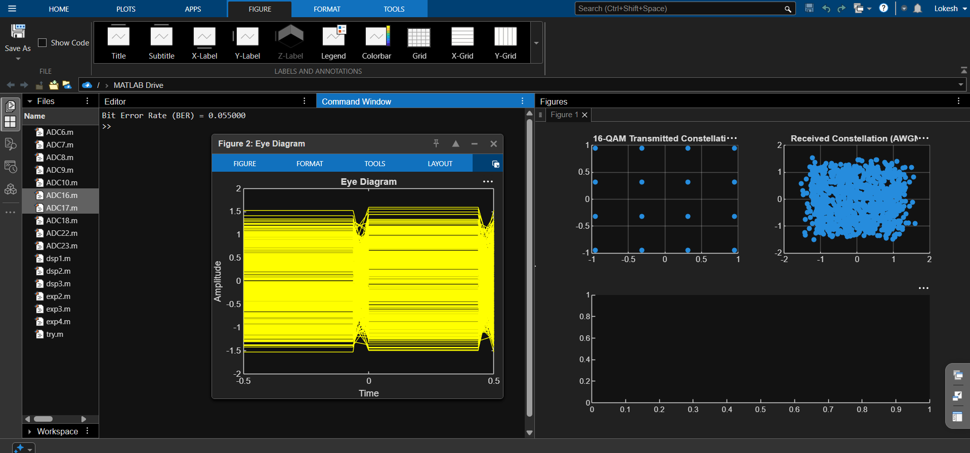
Figure 1: MATLAB output showing transmitted and received 16-QAM constellations and eye diagram.
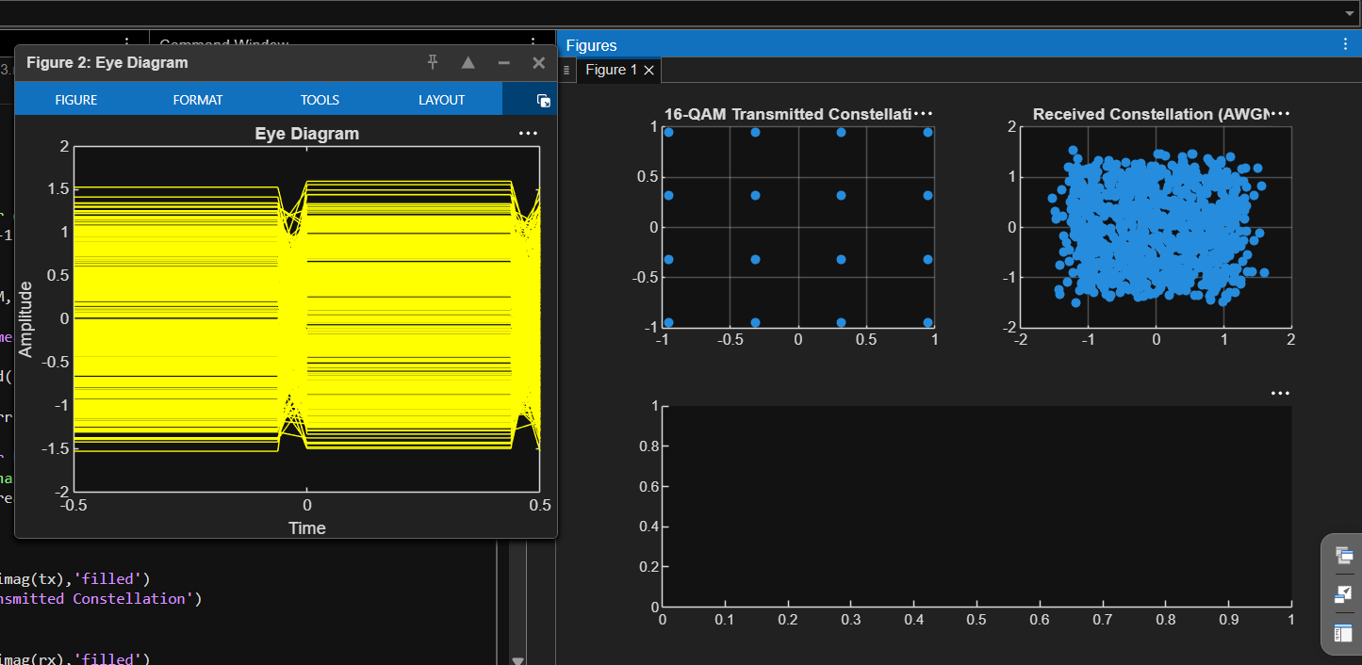
Figure 2: Additional MATLAB output supplied for this experiment.
4. Simulation Parameters
Parameter | Value
Modulation order (M) | 16-QAM
Number of symbols (N) | 1000
Channel model | Additive White Gaussian Noise (AWGN)
Signal-to-noise ratio | 10 dB
Demodulation | 16-QAM demodulation
Performance metric | Bit Error Rate (BER)
Eye signal | Real part of received symbols repeated 8 times
5. Applications
- High-data-rate wireless communication systems.
- Wi-Fi and broadband communication systems that use QAM-family modulation.
- Digital video and data transmission where spectral efficiency is important.
- Testing receiver performance by measuring BER and observing constellation distortion under noise.
6. Alignment with Analog and Digital Communication
This experiment demonstrates digital QAM modulation and demodulation, AWGN channel modelling, BER calculation, constellation analysis and eye diagram visualisation. It connects modulation order and noise effects with the reliability of received digital data.
ADC Concept | Implementation | Observed Output
Symbol generation | randi([0 M-1],N,1) | Random input symbols
16-QAM modulation | qammod(data,M,'UnitAveragePower',true) | Transmitted constellation
Noisy channel | awgn(tx,10,'measured') | Spread received constellation
Demodulation | qamdemod(rx,M,'UnitAveragePower',true) | Detected symbols
BER calculation | biterr(data,data_rx) | BER printed in Command Window
Eye diagram | eyediagram(eyeSig,16) | Eye pattern of real received signal
7. Justification
- Random symbols are used to test the modulation system with a range of possible QAM symbol values.
- 16-QAM carries multiple bits per symbol and provides higher spectral efficiency than lower-order modulation, at the cost of greater sensitivity to noise.
- AWGN introduces channel noise to evaluate how the receiver performs under impaired conditions.
- The transmitted and received constellation plots make symbol displacement due to noise visible.
- BER gives a numerical measure of detected-data errors, while the eye diagram offers a visual view of the received waveform.
8. Conclusion
A 16-QAM communication system was simulated in MATLAB with an AWGN channel at 10 dB SNR. The received symbols were demodulated, the BER was calculated, and constellation and eye-diagram plots were generated. The results illustrate how noise affects QAM symbol locations and how BER and visual plots can be used together to evaluate digital communication performance.
DONE BY
Lokesh A
Register Number: 192512293
B.E. Electronics and Communication Engineering (ECE)

